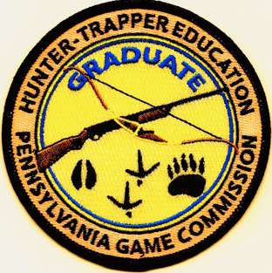
PA Game Commission “Hunter/ Trapper Safety Training”
The Wilmore Sportsman Club is offering the Pa Game Commission
“Hunter/Trapper Safety Training” on April 5th, 2025.
Location: Wilmore Sportsman Club House, 2436 Portage St. Wilmore, PA 15962
Register: on the PA Game Commission Home Page,
-click: apply for a Hunter Safety Course
- click: Find a Hunter -Trapper Education Course
-scroll down: till April 5th is located Wilmore Sportsman
Follow all instructions on page and be sure to read Chapters 1,4,5, and 9 (location on registration page)
All classroom materials will be provided.
Check in time: 8:00am
Class starts promptly: 8:30am
Lunch will be provided also.
All registrants for the event must be 11 years of age by April 5th.

